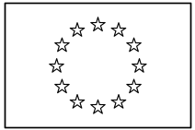 | EUROPEAN COMMISSION  DIRECTORATE-GENERAL  INFORMATICS  Information Systems Directorate

European Commission
CIPADMIN Use Case Specification:
UC0040 - e-TrustEx Admin Console - Manage Profile

Date: | 18/01/201704/09/2015
Version: | 20.000005
Authors: | Anamaria BATRINU
Revised by: | Olivier DERVEAU
Approved by:
Public:
Reference Number:
TABLE OF CONTENTS
1. Use-Case Description 6
1.1. Primary Actor 6
1.2. Definitions, Acronyms and Abbreviations 7
1.3. References 7
1.4. Context Diagram 8
1.4.1. CIPA Administration Console 8
1.4.2. Manage Profile module 8
2. Flow of events 9
2.1. Basic Creation Flow 9
2.1.1. User chooses the Create Profile menu action 9
2.1.2. System displays the "Create Profile" page 9
2.1.3. User enters information 9
2.1.4. System creates the Profile 10
2.1.5. User acknowledges the success of the operation 10
2.1.6. System redisplays the saved profile in view mode 10
2.1.7. The basic creation flow ends. 10
2.2. Basic search flow 10
2.2.1. User selects the Search Profile option 10
2.2.2. System displays the "Search Profile" page 11
2.2.3. User enters the search criteria 11
2.2.4. The System searches the profiles 11
2.2.5. System displays the profiles found 11
2.2.6. User views the result list 11
2.2.7. The basic search flow ends. 11
2.3. Basic Visualization Flow 12
2.3.1. User has successfully saved a profile using the creation/modification flow or at step 2.2.6, User selects a Profile in the list by clicking on it 12
2.3.2. System opens the profile visualization page (see 7.3."View Profile" page) 12
2.3.3. User visualises the details of the profile: 12
2.3.4. Visualization flow ends. 12
2.4. Basic Modification Flow 12
2.4.1. At 2.3.3., User chooses to edit a Profile 12
2.4.2. System opens the Profile page in edit mode (see 7.4."Modify Profile" page): 12
2.4.3. User makes the changes 13
2.4.4. The system saves the modified Profile 13
2.4.5. User acknowledges the successful modification 13
2.4.6. System redisplays the profile in view mode (see 7.3."View Profile" page) 13
2.4.7. The Modification flow ends. 13
2.5. Basic Deletion Flow 13
2.5.1. At 2.3.3., User chooses to delete a Profile 14
2.5.2. System asks for deletion confirmation 14
2.5.3. User confirms the deletion 14
2.5.4. System deletes the profile 14
2.5.5. System notifies user of the success of the operation 14
2.5.6. User acknowledges the message 14
2.5.7. The Deletion Flow ends. 14
2.6. Alternative Flows 14
2.6.1. AC1: at step 2.1.3., User chooses Cancel option 14
2.6.2. AC2: at step 2.1.3, User chooses Clear option 14
2.6.3. ACM1: at step 2.1.4(1) or 2.4.4(1), user clicks OK in the warning popup 14
2.6.4. ACM2: at step 2.1.4(1) or 2.4.4(1), user clicks Cancel in the warning popup 14
2.6.5. AS1: at step 2.2.4, no profiles found for the specified criteria 14
2.6.6. AS2: at step 2.2.3 or 2.2.6, User chooses Cancel option 15
2.6.7. AM1: at step 2.4.3, User chooses Cancel option 15
2.6.8. AM2: at step 2.4.3, User chooses Reset option 15
2.7. Exceptional Flows 15
2.7.1. E1: at steps 2.1.1, 2.2.1, 2.3.1, 2.4.1 or 2.5.1, User is not authorized for the operation 15
2.7.2. E2: at step 2.1.4 or 2.4.4, Business Rules are not verified 15
2.7.3. E3: at step 2.5.4, Business Rules are not verified 15
2.7.4. E4: at step 2.1.4 or 2.4.4, there is an error when saving the profile 15
2.7.5. E5: at step 2.5.4, there is an error when deleting the profile 15
2.7.6. E6: at any step, a technical error occurs 15
3. Special Requirements 16
3.1. Interface(s) with other Systems 16
3.2. Security Requirements 16
3.3. Other Special Requirement 16
4. Preconditions 16
5. Post conditions 16
6. Additional Information 16
6.1. Includes 16
6.2. Extends 17
7. Mock-up screens 17
7.1. "Create Profile" page 17
7.1.1. Create Profile Warning popup 17
7.2. "Search Profile" page 18
7.3. "View Profile" page 18
7.4. "Edit Profile" page 19
7.5. "Delete Profile" page 19
8. Annexes 19
8.1. CIA Levels 19

Document History

Version | Date | Comment | Modified Pages
0.001 | 04/10/2013 | First draft | All
0.002 | 27/02/2014 | Added business domain association
0.003 | 10/04/2014 | Updated Search business rules. | Basic Search Flow: step 3.2.4
0.004 | 20/11/2014 | Modifications following model change over time.
0.005 | 04/09/2015 | JIRA CIPADMIN-406 | Added BR40_16
0.006 | 26/10/2016 | ETRUSTEX-1392
2.000 | 18//01/2017 | ETRUSTEX-1937: Reorganizing CIPAdmin user roles
2.001 | 09/03/2017 | Related to ETRUSTEX-2468: clarifying the behaviour of the warning displayed with UC40_BR07. | Added AC3 & AC4 and section 7.1.1
2.002 | 10/03/2017 | ETRUSTEX-2472 | Updated UC40_BR15

Use-Case Description
This use case depicts the sequence of actions to be followed by a user in order to create a Profile. It also describes the management actions that correspond to a created Profile, such as Update, Delete, View and Search.
The "Profile Management" service is exposed on the CIPAdmin module of e-Trustex platform.
In the remainder of the document the CIPADMIN application will be referred to as the System.

Primary Actor
A human user can access the Manage Profile feature via CIPAdmin interface.

For detailed user access rights on each feature option, please see UC 0100 - eTrustEx Admin Console - Authenticate and Authorise User, section 6.3 User Access Rights.
In the remainder of the document, the user will be referred to as User.

Definitions, Acronyms and Abbreviations
Acronym, Abbreviation or Definition | Explanation
CIPA | Common Infrastructure for Public Administrations
CIPADMIN | CIPA AdminConsole
ADM | A user having General Administrator role. The General Administrator is the Administrator of the CIPAdmin application.
CBO | A user having Central Business Owner role. The Central Business Owner is responsible for the organization and operation of a business domain and uses CIPA in his business context.
UC(s) | Use Case(s)
CIA | Confidentiality Integrity Availability

References
Ref. | Reference | Title / description | Version | Date
[R1] | CIPADMIN-VISION | CIPADMIN Vision document | V.61-EN | 18/04/2013

Context Diagram

CIPA Administration Console
The diagram below depicts all the Services available on the CIPA Administration Console for e-TrustEx platform. Depending on the user role, only a subset of those services is exposed on the e-TrustEx Administration Console home page.
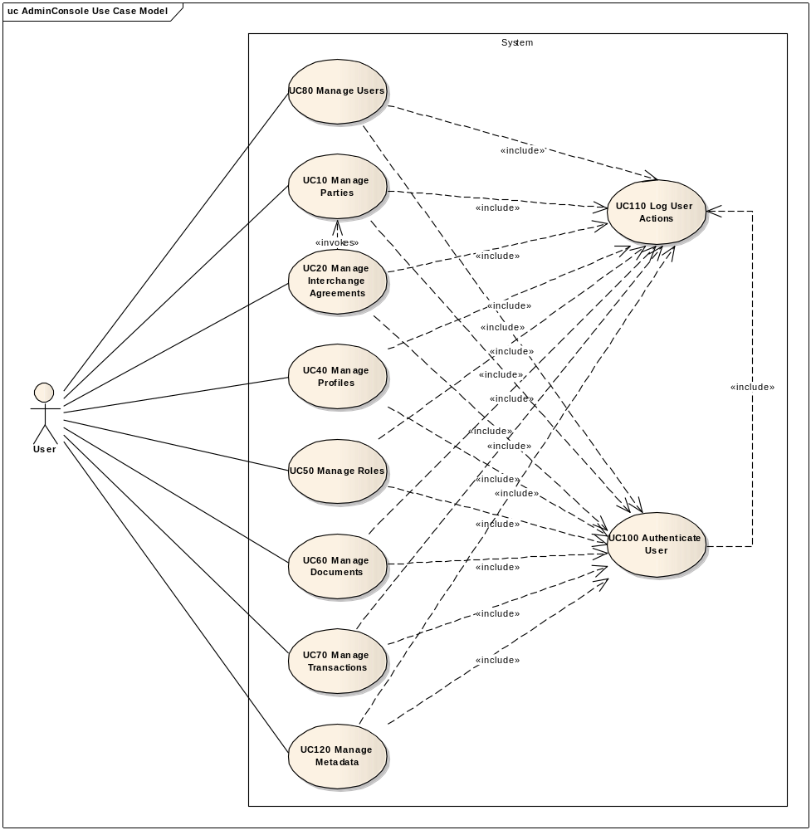

Manage Profile module
The diagram below depicts how this use case interacts with other use cases implemented in the Administration Console.
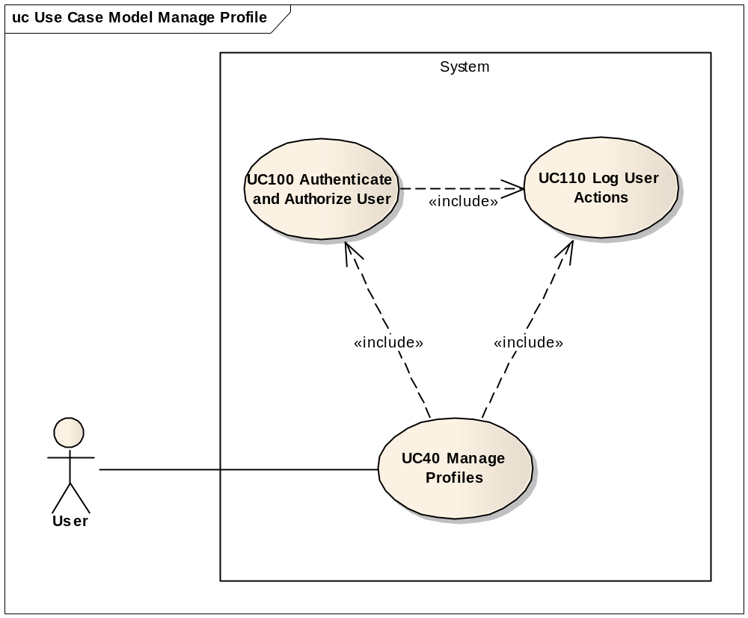

Flow of events
The conventions described in User Interface Generic Conventions document must be applied.

Basic Creation Flow

User chooses the Create Profile menu action
ID | Description
UC40_BR01 | User needs to have the correct access rights in order to access this feature. Please see UC 0100 - eTrustEx Admin Console - Authenticate and Authorise User, section 6.3 User Access Rights for more information.
User selects Technical Configuration > Profile > Create from e-TrustEx Administration Console home page.

System displays the "Create Profile" page
The System displays the Create Profile page as described in paragraph 7.1."Create Profile" page.

User enters information
- User fills in
- Profile name
- Profile namespace
- User chooses
  - CIA: defaulted to the most permissive CIA levels; please see 8.1 CIA Levels for more details
  - from the transaction list/table, the transactions to be used in the context of this profile
- User chooses save option.

System creates the Profile
ID | Description
UC40_BR02 | Profile name is mandatory.
UC40_BR16 | Profile name must not exist.
UC40_BR03 | Profile namespace is mandatory.
UC40_BR04 | An option is mandatory for the profile business domain. If "None" option has been chosen, the profile will be created without being associated to a profile at the creation time.
UC40_BR05 | User shall be authorised for the selected profile business domain(s).
UC40_BR06 | The CIA levels are mandatory.
UC40_BR07 | User is warned if no transaction is selected. You may see 7.1.1 Create Profile Warning popup.
- System validates the page according to the business rules.
- System saves the Profile, and creates a CIA levels record if it does not exist. It also creates the associations between the profile and the selected business domains or transactions if any selected.
- System logs the successful creation of the profile: include use case Log CIPAdmin User Actions
- System informs the user about the success of the operation

User acknowledges the success of the operation

System redisplays the saved profile in view mode
- System goes to step 2.3.2 in 2.3. Basic Visualization Flow

The basic creation flow ends.

Basic search flow

User selects the Search Profile option
ID | Description
UC40_BR01 | User needs to have the correct access rights in order to access this feature. Please see UC 0100 - eTrustEx Admin Console - Authenticate and Authorise User, section 6.3 User Access Rights for more information.
There are two ways of accessing the Search Profile option:
- By selecting the menu action Technical Configuration > Profile > Search from the e-TrustEx Administration Console home page
- By selecting the Search option from one of the application pages that uses it. Note that, in this case, the search page described in paragraph 7.2. "Search Profile" page will have a Cancel option allowing the user to leave the search page and go back to the parent page without any information being exchanged.

System displays the "Search Profile" page
System displays the search page as described in paragraph 7.2. "Search Profile" page.

User enters the search criteria
- User enters one or more search criteria. A search criterion left empty means the concerned field will not be taken into account.
- User activates the search button.

The System searches the profiles
ID | Description
UC40_BR08 | A field left empty will not be taken into account for the search.
UC40_BR09 | Character case is ignored.
UC40_BR10 | Trailing and leading spaces are ignored.
UC40_BR11 | For the profile and transaction name, field value can contain a partial match.
The system searches the profiles that satisfy all the entered criteria.

System displays the profiles found
The system displays the list of profiles corresponding to the search criteria, showing the following information:
  - Profile name
  - Profile namespace
  - Profile business domain
  - CIA levels

User views the result list
- User can view the details of a profile by clicking on its name in the list (see 2.3. Basic Visualization Flow)
- If called from a master screen instead of the menu option
  - User selects a record in the result list (by clicking on it)
  - System returns the record to the master screen in order to be used by the caller flow
  - Go to section 2.2.7. The basic search flow ends
- User can launch a new search

The basic search flow ends.

Basic Visualization Flow
ID | Description
UC40_BR01 | User needs to have the correct access rights in order to access this feature. Please see UC 0100 - eTrustEx Admin Console - Authenticate and Authorise User, section 6.3 User Access Rights for more information.

User has successfully saved a profile using the creation/modification flow or at step 2.2.6, User selects a Profile in the list by clicking on it

System opens the profile visualization page (see 7.3."View Profile" page)

User visualises the details of the profile:
- User can choose to edit or to delete a Profile (see 2.4 Basic Modification Flow and 2.5. Basic Deletion Flow), if they have the corresponding access rights. Please see UC 0100 - eTrustEx Admin Console - Authenticate and Authorise User, section 6.3 User Access Rights for more information.
- User can choose Cancel option, to leave the visualization screen
  - If Visualization <= Search (i.e. visualization initiated from Search flow) or Visualization <= Modification <= Visualization <= Search (i.e. visualization initiated from Modification flow, and Modification flow called from the visualization flow that followed a search flow), System returns the User to the search screen: the view flow ends and basic search flow continues at 2.2.6
  - If Visualization <= Creation or Visualization <= Modification <= Visualization <= Creation, System return the User to a new creation screen: the view flow ends and a new basic creation flow starts

Visualization flow ends.

Basic Modification Flow
ID | Description
UC40_BR01 | User needs to have the correct access rights in order to access this feature. Please see UC 0100 - eTrustEx Admin Console - Authenticate and Authorise User, section 6.3 User Access Rights for more information.

At 2.3.3., User chooses to edit a Profile

System opens the Profile page in edit mode (see 7.4."Modify Profile" page):
ID | Description
UC40_BR12 | All fields but the profile can be modified if no interchange agreement using this profile exists in the System.  If an interchangte agreement exists for the profile, then the selections of business domains and transactions associated to the profile cannot be changed. This check shall be done twice:  - First, when accessing the modification page, which will make the lists protected  - Second, when trying to save a modified transaction (in order to ensure that no ICA using this profile has been created in the meanwhile)  Note: This serves to avoid inconsistency with the ICAs containing this profile and used for authorisation checks for messages sent before this point, and the ones used for message authorisation after this point. There is still a very small chance that this will happen, in the milliseconds between the second check and the execution of the save operation.
UC40_BR02 | Profile name is mandatory.
UC40_BR16 | Profile name must not exist.
UC40_BR03 | Profile namespace is mandatory.
UC40_BR04 | The profile business domain is mandatory.
UC40_BR06 | The CIA levels are mandatory.
UC40_BR13 | User can add/remove transactions to/from the profile by checking/unchecking them.
UC40_BR07 | User is warned if no transaction is selected.

User makes the changes
- User makes the desired changes
- User chooses the save option

The system saves the modified Profile
- The system validates the page according to the business rules.
- The system saves the Profile, and creates a CIA levels record if it does not exist. It also updates the list of transactions associated to it depending on user selection.
- System logs the successful modification: include use case Log CIPAdmin User Actions
- The System informs the user about the success of the operation

User acknowledges the successful modification

System redisplays the profile in view mode (see 7.3."View Profile" page)

The Modification flow ends.

Basic Deletion Flow
ID | Description
UC40_BR01 | User needs to have the correct access rights in order to access this feature. Please see UC 0100 - eTrustEx Admin Console - Authenticate and Authorise User, section 6.3 User Access Rights for more information.
UC40_BR14 | Profile cannot be deleted if it is used in an interchange agreement, by an end point, message response code, metadata item or retention policy configuration.
UC40_BR15 | Any association of the profile to a business domain or a transaction shall be removed before deletion, as well as any event notification configuration record linked to this profile.

At 2.3.3., User chooses to delete a Profile

System asks for deletion confirmation

User confirms the deletion
If user chooses to cancel the deletion, he is returned to the visualization page (2.3.3.).

System deletes the profile
- System verifies the business rules
- System deletes profile
- System logs the successful deletion: include use case Log CIPAdmin User Actions

System notifies user of the success of the operation

User acknowledges the message

The Deletion Flow ends.

Alternative Flows

AC1: at step 2.1.3., User chooses Cancel option
- System disregards all information provided by User
- System closes the page
- System redirects the user to CIPAdmin home page
- Use Case ends

AC2: at step 2.1.3, User chooses Clear option
- Systems disregards all information provided by the user
- Alternate flow ends and basic creation flow restarts at 2.1.2.

ACM1: at step 2.1.4(1) or 2.4.4(1), user clicks OK in the warning popup
- System closes the warning popup
- System continues from 2.1.4(2), or 2.4.4(2) respectively.

ACM2: at step 2.1.4(1) or 2.4.4(1), user clicks Cancel in the warning popup
- System closes the warning popup.
- System redisplays the creation page in the same state as before displaying the warning popup
- User may continue from 2.1.3 or 2.4.3 respectively.

AS1: at step 2.2.4, no profiles found for the specified criteria
- The system notifies the user that no Profiles have been found
- Alternate flow ends and basic search flow restarts at 2.2.3

AS2: at step 2.2.3 or 2.2.6, User chooses Cancel option
- System closes Search screen
- System returns to parent screen
- Search flow ends and caller flow can now continue

AM1: at step 2.4.3, User chooses Cancel option
- System disregards all information provided by User
- System closes the page
- Alternate flow ends and basic flow continues from step 2.3.2

AM2: at step 2.4.3, User chooses Reset option
- Systems disregards all information provided by the user
- Alternate flow ends and basic modification flow restarts at 2.4.2.

Exceptional Flows

E1: at steps 2.1.1, 2.2.1, 2.3.1, 2.4.1 or 2.5.1, User is not authorized for the operation
Include the steps in section 2.4.1 of Authenticate and Authorise User Use Case.

E2: at step 2.1.4 or 2.4.4, Business Rules are not verified
- System logs the error: include use case Log CIPAdmin User Actions
- System highlights the field(s) in error
- System informs User about the error(s)
- Flow restarts at 2.1.3, respectively 2.4.3.

E3: at step 2.5.4, Business Rules are not verified
- System logs the error: include use case Log CIPAdmin User Actions
- System informs User about the error(s)
- Flow restarts at 2.3.3.

E4: at step 2.1.4 or 2.4.4, there is an error when saving the profile
- System logs the error: include use case Log CIPAdmin User Actions
- System informs the user about the error
- Use Case ends

E5: at step 2.5.4, there is an error when deleting the profile
- System logs the error: include use case Log CIPAdmin User Actions
- System informs the user about the error
- Use Case ends

E6: at any step, a technical error occurs
- System logs the error: include use case Log CIPAdmin User Actions
- The system informs the user about the error.
- Use case ends.

Special Requirements

Interface(s) with other Systems

Security Requirements

Other Special Requirement

Preconditions
N/A

Post conditions
- [Success] The Profile has been successfully created / modified / deleted.
- [Failure] The use case is aborted and the primary actor has been notified of the reasons.

Additional Information

Includes
- For operation authorization: UC 0100 - eTrustEx Admin Console - Authenticate and Authorise User
- For logging: UC 0110 - eTrustEx Admin Console - Log CIPAdmin User Actions

Extends

Mock-up screens

"Create Profile" page
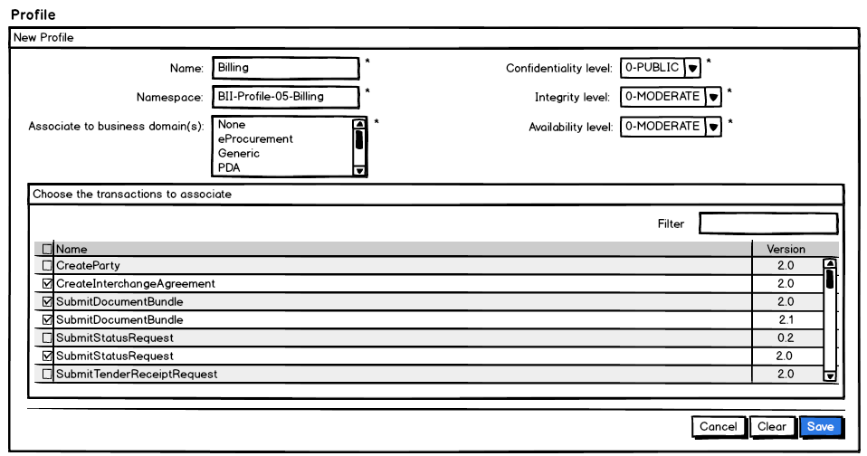
- System populates the lists for the CIA levels with the levels and their descriptions. Please see 8.1 CIA Levels for more details. The selection shall be defaulted to the most permissive CIA levels.
- System populates the business domain multiple choice list with all the business domains the user is authorised for and defaults the selection to "None".
- System retrieves a list with all available transactions and populates the transaction list/table. A filter option is present to facilitate finding the transactions to associate to the profile. The list shall be alphabetically ordered in ascendant order and ignoring case.
- Starred fields are mandatory.
- Cancel, Clear and Save options are present.

Create Profile Warning popup
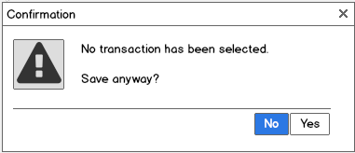

  - "Search Profile" page
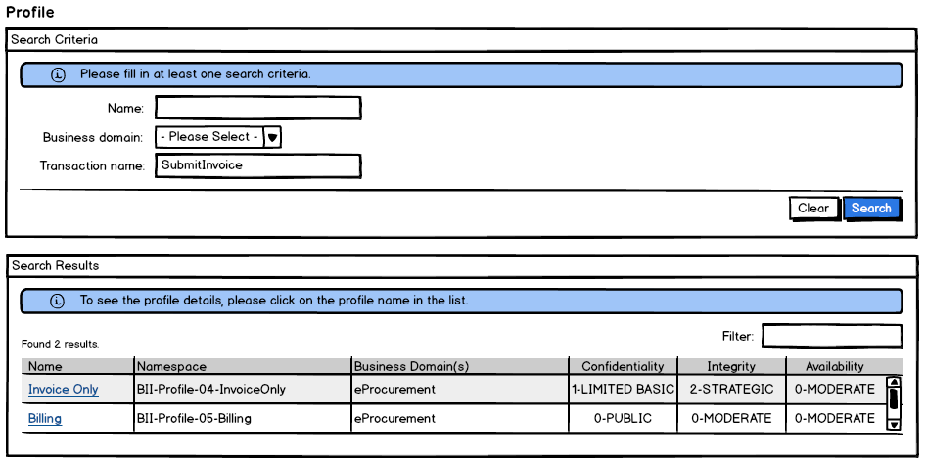
- System populates the business domain list with the User's business domains.
- The business domain and results lists shall be alphabetically ordered in ascendant order and ignoring case and shall contain the following information:
- Profile name
- Profile namespace
- Profile business domains (if more than one, they will be shown each on a new line in the same cell)
- CIA levels and their description

"View Profile" page
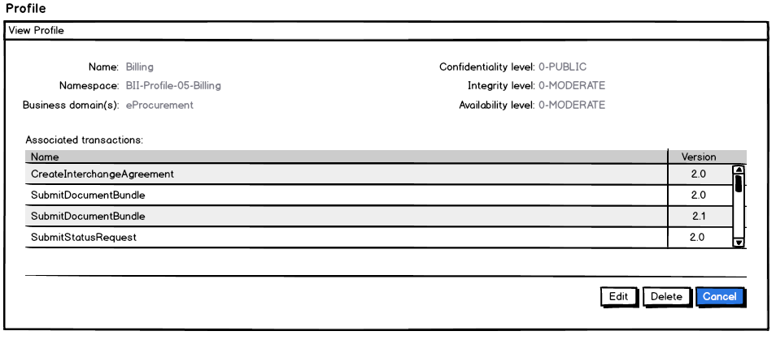
- All fields are protected
- The transaction list is alphabetically ordered in ascendant order and ignoring case.
- "Cancel", "Edit" and "Delete" buttons are made available

"Edit Profile" page
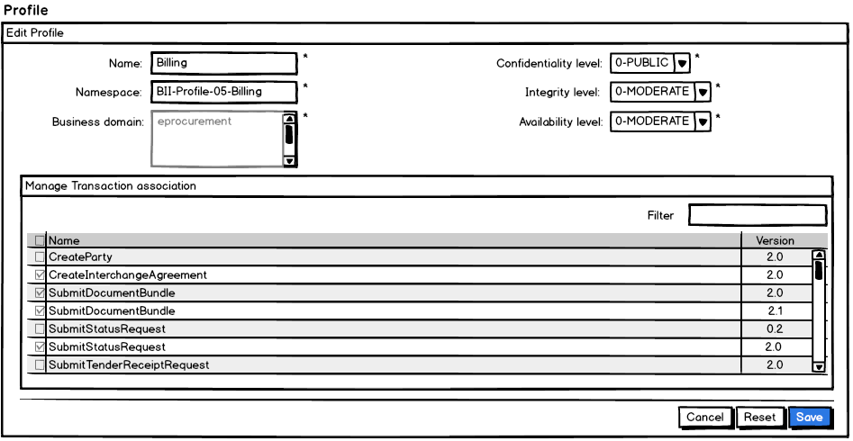
- Starred fields are mandatory.
- Business domains and transactions selections can be modified or not, depending on the existence of an ICA with the profile. In case they are not modifiable they shall be protected (as in the mockup screen above).
- The transaction list is alphabetically ordered in ascendant order and ignoring case.
- Cancel, Reset and Save options are present.

"Delete Profile" page
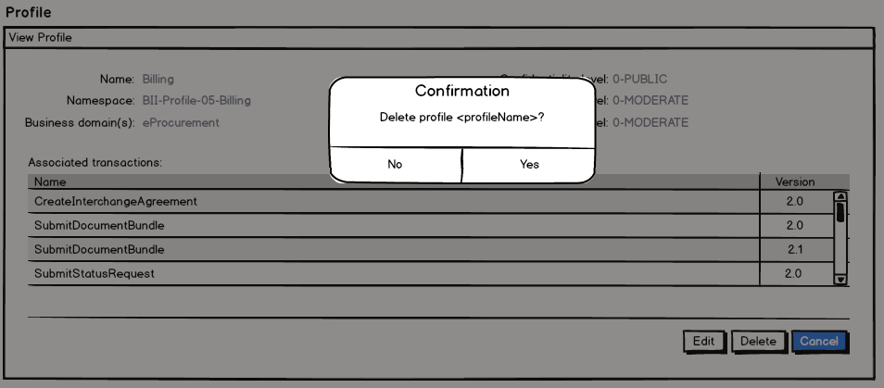

Annexes

CIA Levels
The possible values for CIA levels can be found in the table bellow:
Classification criteria | Level | Description
Confidentiality | 0 | PUBLIC
Confidentiality | 1 | LIMITED BASIC
Confidentiality | 2 | LIMITED HIGH
Integrity | 0 | MODERATE
Integrity | 1 | CRITICAL
Integrity | 2 | STRATEGIC
Availability | 0 | MODERATE
Availability | 1 | CRITICAL
Availability | 2 | STRATEGIC
The most permissive levels are the lowest levels. The higher a CIA level, the less permissive it becomes.

